Curriculum Vitae
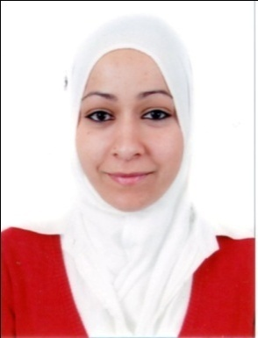
HAMAMOUSSE Amina
Date and place of birth: September 10th 1989 at Oran (Algeria)
Adress : 07 impasse Messameh Kaddour Miramar, Oran, Algérie.
Phone number : +213 794 07 37 26
e-mail : a.hamamousse@gmail.com
Single
HIGHER DEGREES EDUCATION
- Sine October 2013: PhD degree in preparation at University of Oran 2 Mohamed Ben Ahmed, in the field of Monetary and Financial Economics.
Thisis title: Taylor rule and monetary policy in Algeria
- June 2013: Master degree in Economics; option Banks and insurance with high honors
- June 2011: University degree in Economics sciences, option Finance money bank with high honors.
- June 2007: Baccalaureate in Natural Sciences.
PROFESSIONAL EXPERIENCE
- October 2011 to now: Financial Analyst at People's Assembly of Oran - Algeria
SCIENTIFIC ACTIVITIES
- HAMAMOUSSE, A. (May, 2017). Règle de Taylor et politique monétaire en Algérie, Second doctoral day, University of Oran 2 Mohamed Ben Ahmed, (Poster Communication).
- HAMAMOUSSE, A. & MAAMAR, B. (2016). Étude des fluctuations du taux directeur en Algérie (1990-2015). Revue Économie & Gestion. Vol 10. No 1. pp 210-219
EDUCATIONAL ACTIVITIES
- 2016 /2017: Associate teacher for Microeconomics module and Monetary and financial economics at university of Oran 2 Mohamed Ben Ahmed, Faculty of economics, management, and commercial sciences.
- Tutoring Mission for First-Year Students at university of Oran 2 Mohamed Ben Ahmed, Faculty of economics, management, and commercial sciences.
- 2014 /2015: Associate teacher for Macroeconomics module at university of Oran 2 Mohamed Ben Ahmed, Faculty of economics, management, and commercial sciences.
- 2013/2014: Associate teacher for methodology module and International finance module at university of Oran 2 Mohamed Ben Ahmed, Faculty of economics, management, and commercial sciences.
TRAINEESHIPS, MEMBER OF ORGANISATIONS AND LEARNINGS
- Since November 20th 2016, till December 19th 2016 : Internship at the industry, institutions and economic systems research center of Amiens « CRIISEA », University of Picardie Jules Verne « UPJV », Amiens, France.
- 2011/2012: Member of « SINAAT ELHAYAT », WARID group for awareness and blood donation
- Since September 04th 2011, till October 23rd 2011: Traineeship at SONATRACH, AVAL activity, LQS, GP1/Z, Finance and legal department.
- Since April 12th 2011, till July 12th 2011: Traineeship at National Bank of Algeria, commercial promotion & animation department
ATTITUDES AND PERSONAL QUALITIES
- Arabic mother tongue, French (very good level), English (Good level).
- Passionate reading (novels and historical books).
- Sporty (swimming) and passionate about chess.
- Good knowledge on computer science tools and software (Word, Excel, Power Point, Eviews, Winrats …)
- Dynamic, passionate, motivated, sense of responsibility and organization.

